CHAPTER 4

Results and Discussion

In this chapter, the results of the project evaluation are discussed. The chapter covers a comprehensive description of the project, its structure, capabilities, limitations, and the evaluation process.

Project Description

Rock Quest is a 3D platformer mobile learning game focused on rocks and minerals. This study aimed to design and develop a game that would counter the traditional methods of teaching Earth Science, engaging students in a fun and interactive way of learning.
The game comprises four main modules which are the Adventure mode, Almanac, and the two minigames, Quiz and Hidden Object.The main module of the 3D Platformer Game is the Adventure mode, which consists of three maps: Mountain Ranges, Beach, and Volcano, each containing three levels. The design of the maps is based on the three classifications of rocks to help players familiarize themselves with different types of rocks. The rocks collected during gameplay are stored in the Almanac Module, which utilizes local storage to store information about the rocks and their uses. On the other hand, the Hidden Object module focuses on minerals found in society and also consists of three levels: the living room, the bedroom, and the kitchen. In this module, players must find the item described in a riddle to learn which mineral it represents.
The Quiz module consists of three levels which was also based on the three maps on the adventure mode. This module was implemented using the Fisher-Yates Algorithm to shuffle the questions.
Additionally, the developers carried out an evaluation of Rock Quest: The Development of a 3D platformer game about Rocks and Minerals for the STEM Senior High School students at Jesus Flock Academy. The evaluation was based on the ISO-9126 Standard Evaluation tool, focusing on six qualities:

Functionality, Reliability, Usability, Efficiency, Maintainability, and Portability. The collected data will be analyzed to assess whether the mobile game successfully meets its objectives in terms of delivery, design, and functionality.

Project Structure (note: All figures provided here serve as evidence that the objectives, both general and specific, have been successfully achieved. Each figure's description is presented within the technical discussion to ensure clarity and alignment with the objectives

The structure of a mobile game application is crucial for its development, covering its design, dimensions, specifications, as well as its modules and features. Through careful planning and design of the project structure, developers can craft a game that is engaging, user-friendly, and customized to the preferences and needs of their target audience.
The following figures show the modules of the game as well as its functions.

Figure 20

Username Dialog
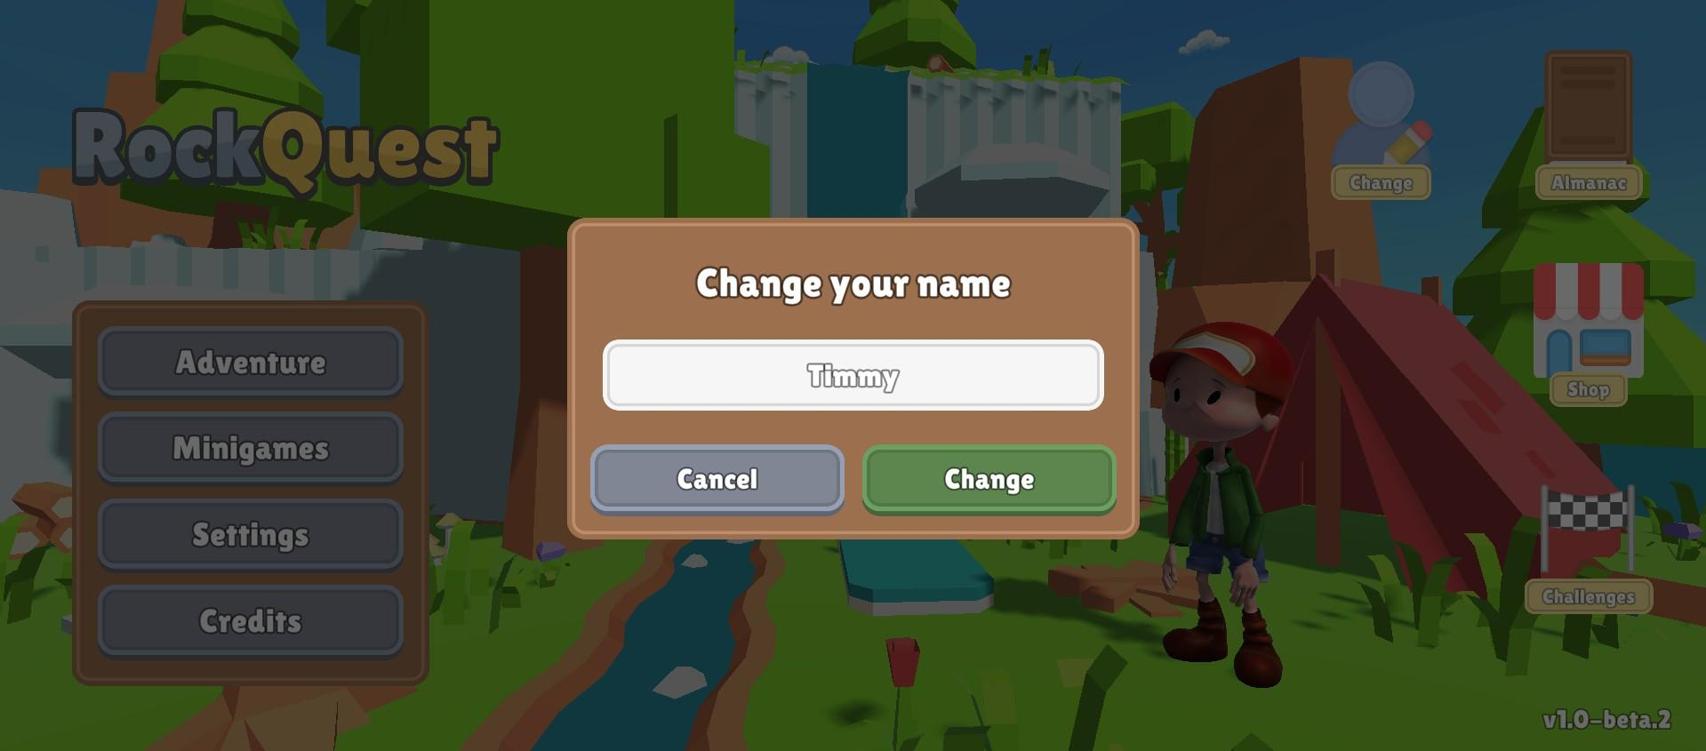

Figure 20 showcases the username dialogue feature, allowing users to input their desired username directly into the game. Researchers utilize event handling for real-time updates and validation to ensure usernames meet certain criteria.

Figure 21

Main Menu
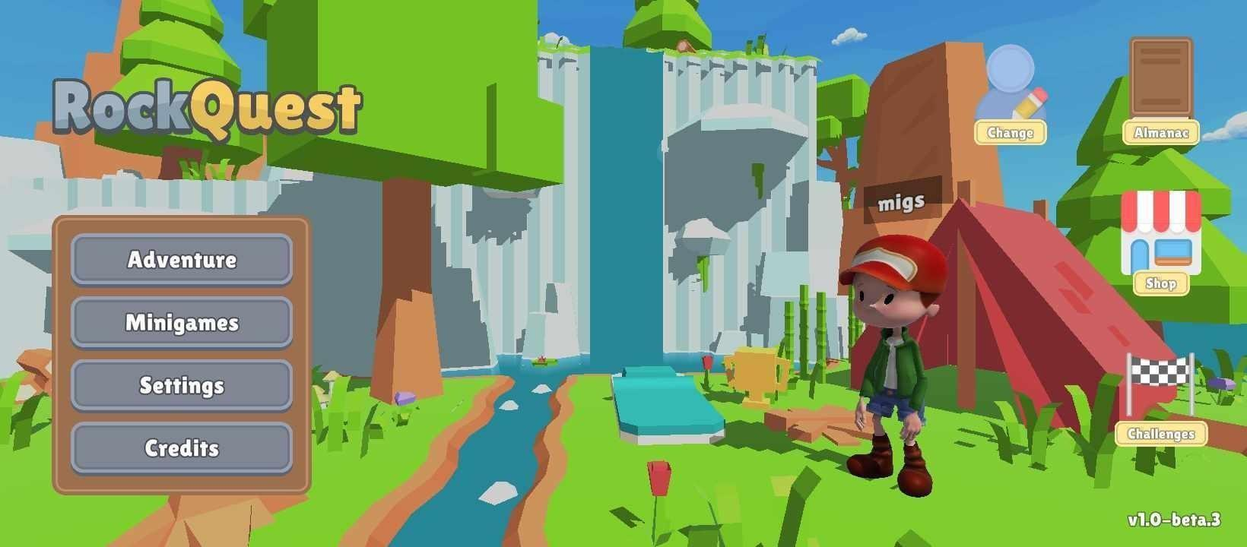
Figure 21 exemplifies the game's main menu, designed for easy navigation. This implementation involves utilizing Unity UI components and C# scripts to seamlessly integrate modules such as user profile, almanac, shop, challenges, Adventure mode, minigames, settings, and credits.
Figure 22
Settings
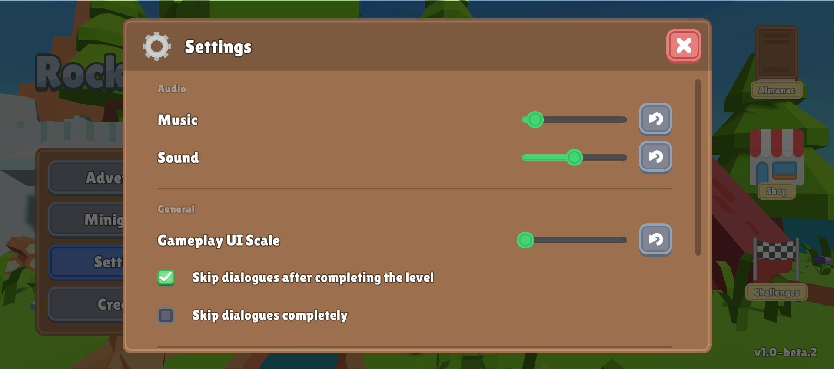

Figure 22 showcases the settings interface, enabling users to customize audio levels, UI scale, dialogue controls, reset game data, and report bugs. This implementation involves utilizing Unity UI components

and settings management system using C# scripts to handle user preferences and configurations for seamless integration and functionality.
Figure 23
Almanac
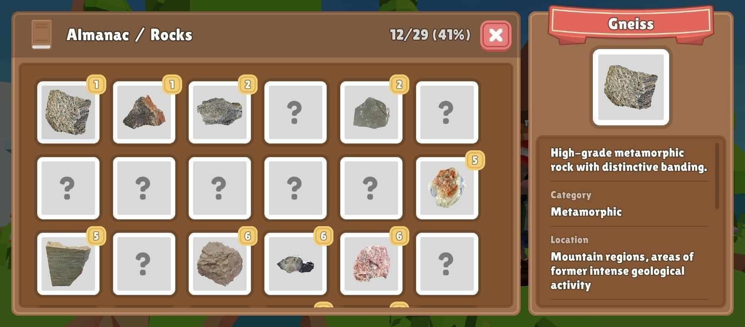
Figure 23 showcases the Almanac, presenting descriptions and images of collected rocks from Adventure mode. This functionality is achieved through the integration of Unity's UI elements, such as scroll views and text components, along with C# scripts handling data retrieval and display logic.
Figure 24
Shop
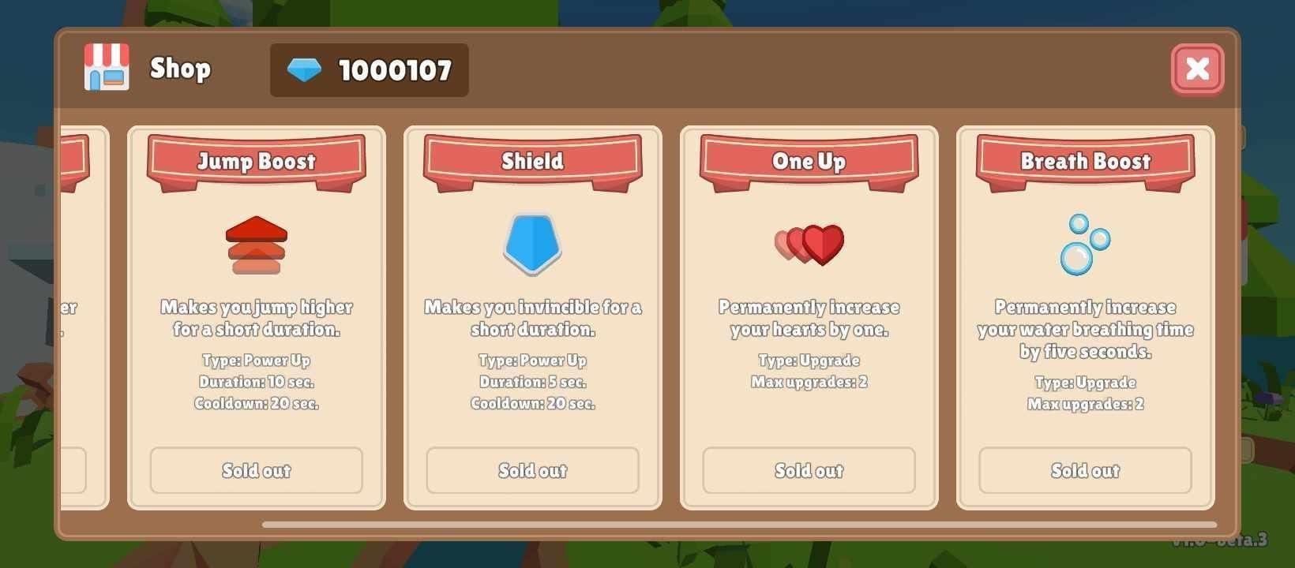

Figure 24 showcases the in-game shop interface, designed using Unity's UI components such as buttons, panels, and text elements. C# scripts are utilized to manage currency transactions, power-up availability, and user interactions within the shop environment.

Figure 25
Challenges
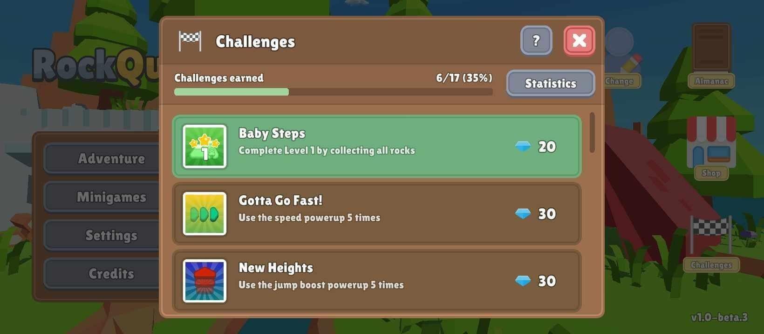
Figure 25 presents the challenges list, leveraging Unity UI components like scroll views and text elements for display. C# scripts manage challenge completion using PlayerPrefs data and calculate player progress, displaying counts and percentages accordingly.

Figure 26
Statistics
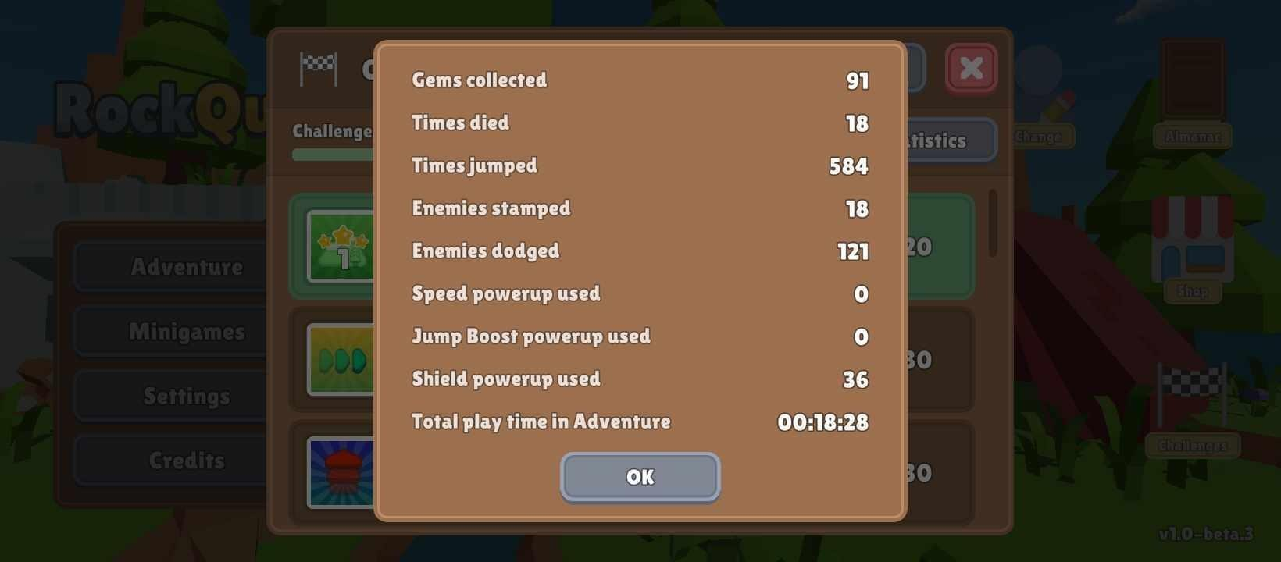
Figure 26 illustrates the player's gameplay statistics, utilizing Unity's UI components for presentation, such as text fields. C# scripts dynamically update and gather data from saved PlayerPrefs, providing real-time insights into the player's performance during Adventure levels.
Figure 27
Minigame Selection
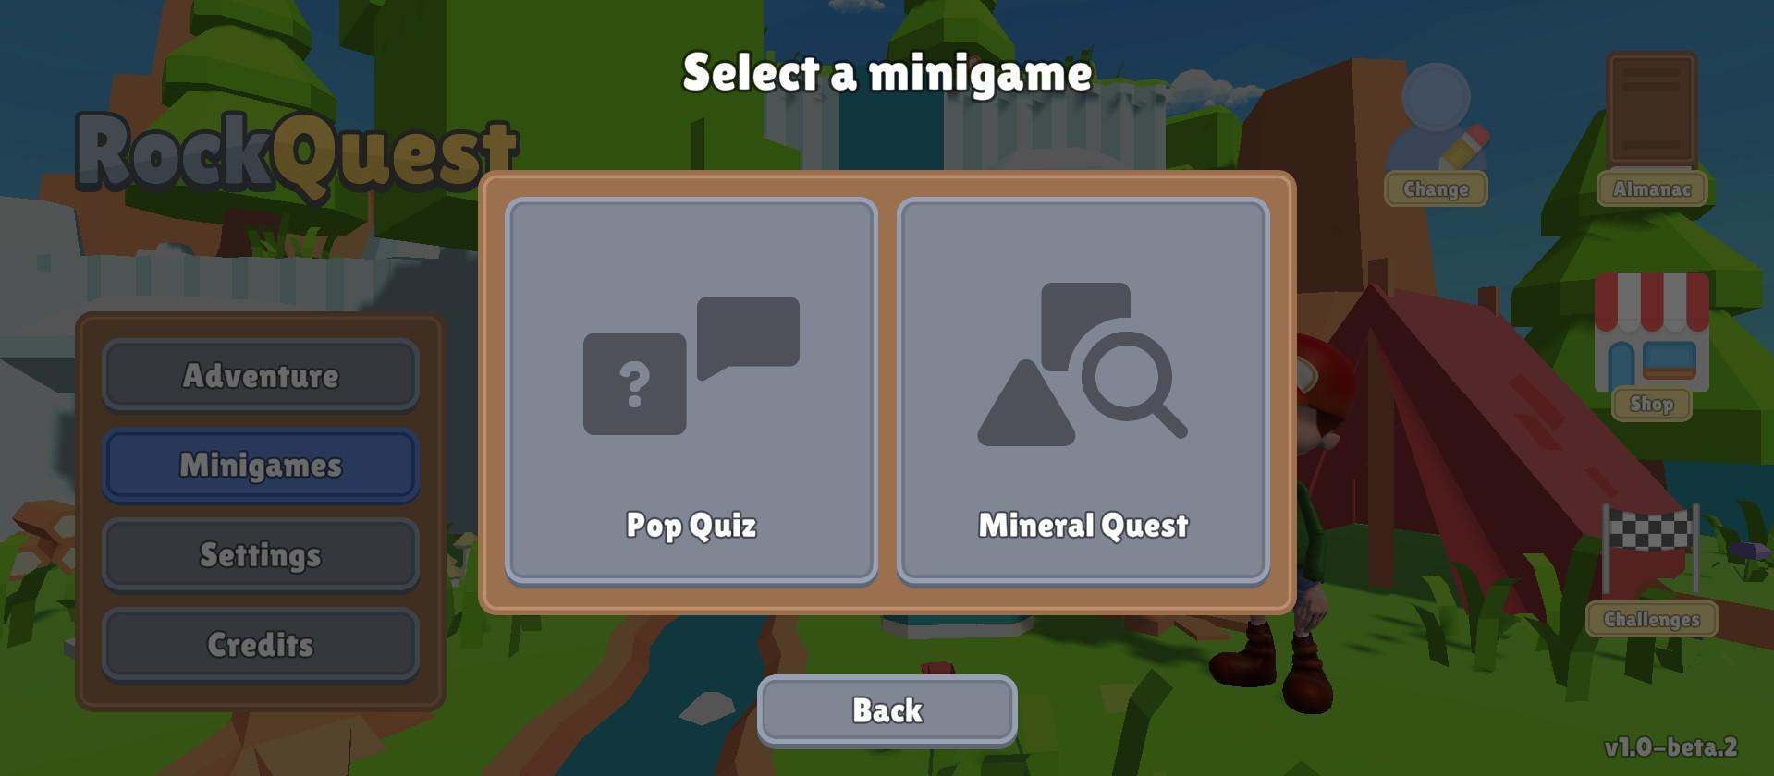

Figure 27 displays the Minigame selection interface featuring Pop Quiz and Mineral Quest options. Utilizing Unity UI buttons, SceneLoader class in C# scripts facilitate navigation, determining the player's choice and loading the respective minigame scene accordingly.

Figure 28
Fisher-Yates Algorithm
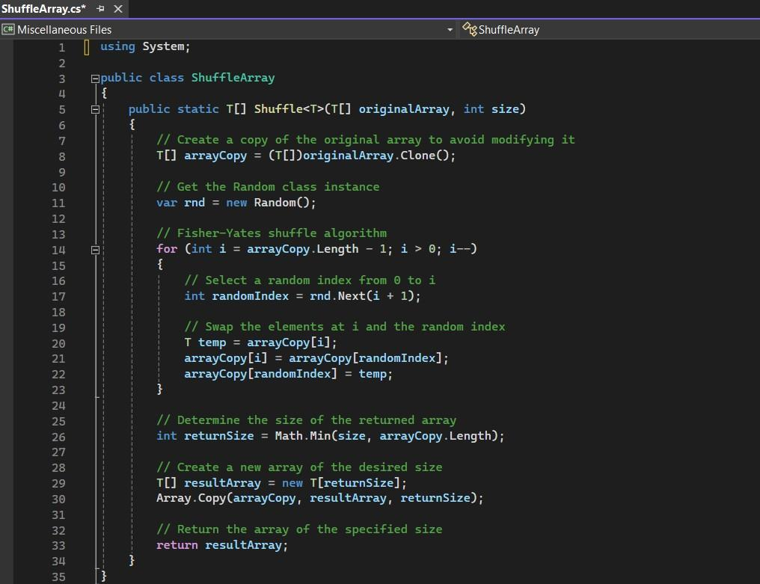
Figure 28 shows the implementation of Fisher Yates Algorithm to the Quiz Module of the Game. On line 14, the algorithm was implemented to shuffle the number of arrays and to select the random index as well as to swap it randomly.

Figure 29
Pop Quiz level selection
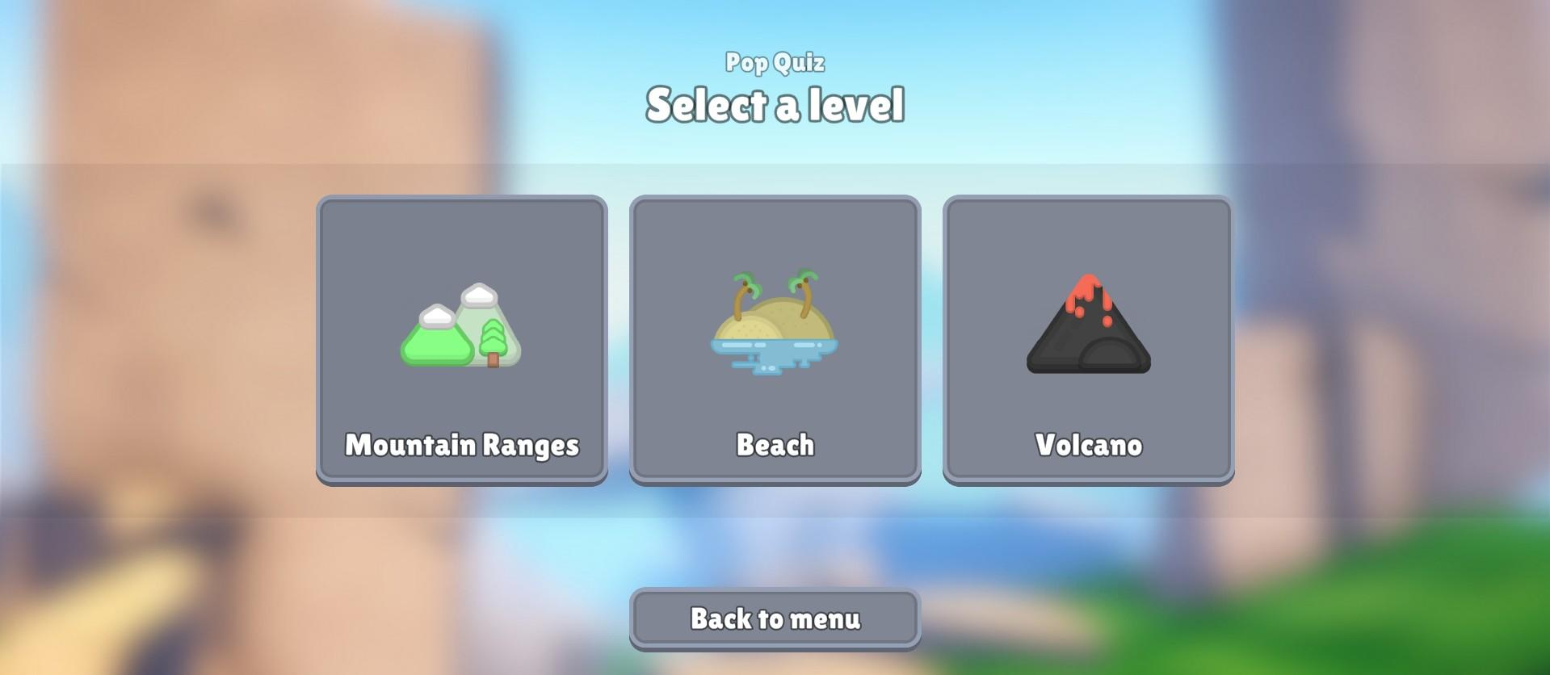
Figure 29 showcases the Quiz level selection interface, comprising three locked levels based on Adventure module maps. These levels are unlocked upon completing corresponding Adventure levels. The implementation utilizes Scriptable Objects to store and manage level data, facilitating seamless integration and dynamic unlocking mechanics.

Figure 30
Pop Quiz
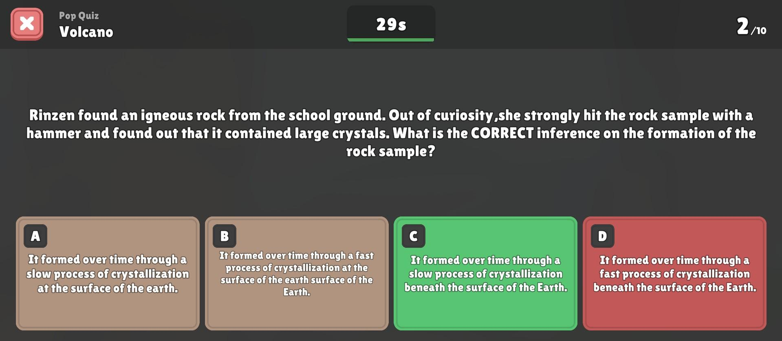

Figure 30 presents the Quiz Module, featuring 10 questions, each with a timer. Utilizing Unity UI elements for question presentation, C# scripts manage three question types: multiple choice, text input, and word scramble. Points are awarded for correct answers within the time limit, with the timer dynamically adjusting based on player response time.

Figure 31
Mineral Quest level selection
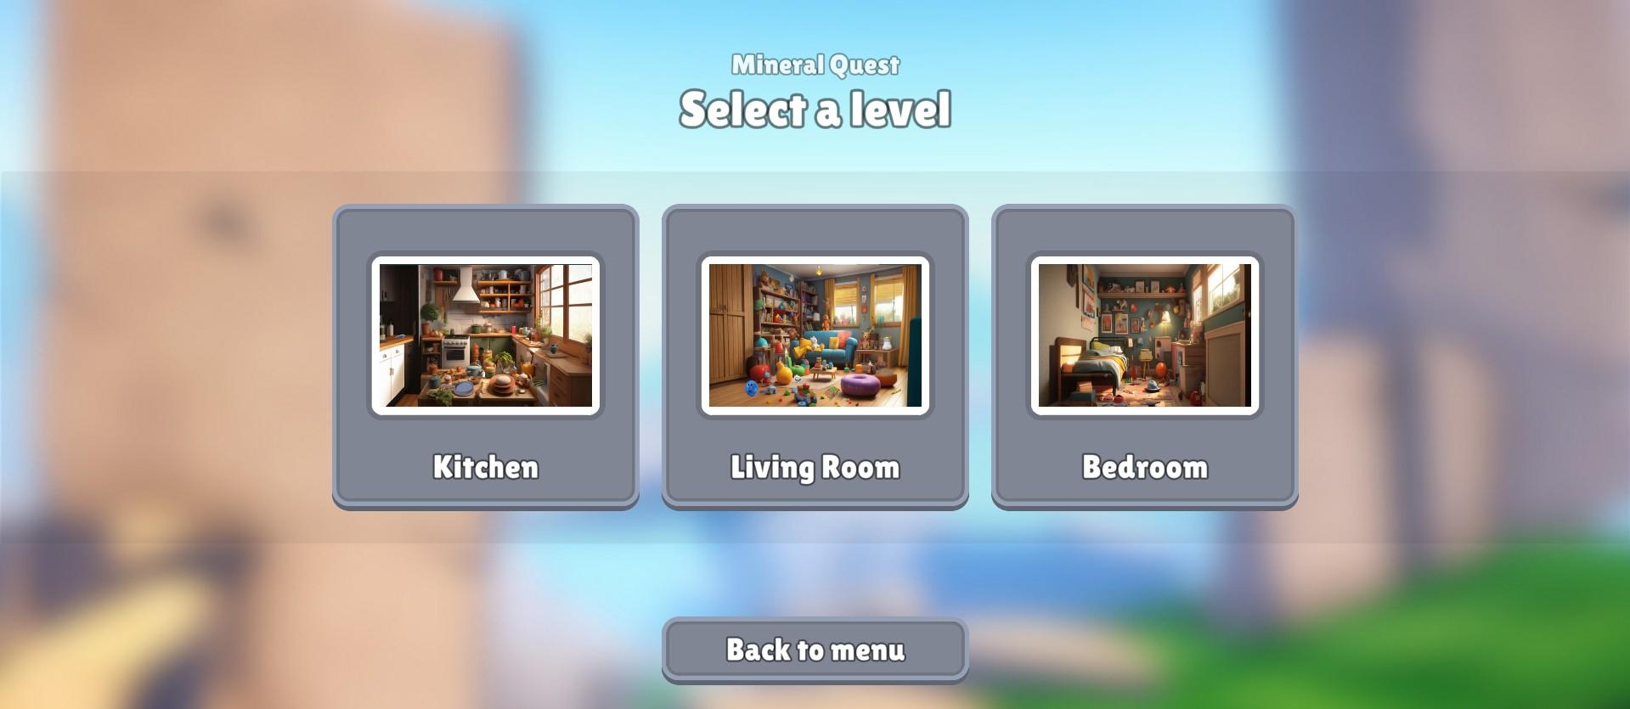
Figure 31 depicts the Mineral Quest level selection interface, leveraging Scriptable Objects to store and manage data pertaining to each level. This implementation ensures efficient organization and accessibility of level information within the game.

Figure 32
Mineral Quest Kitchen
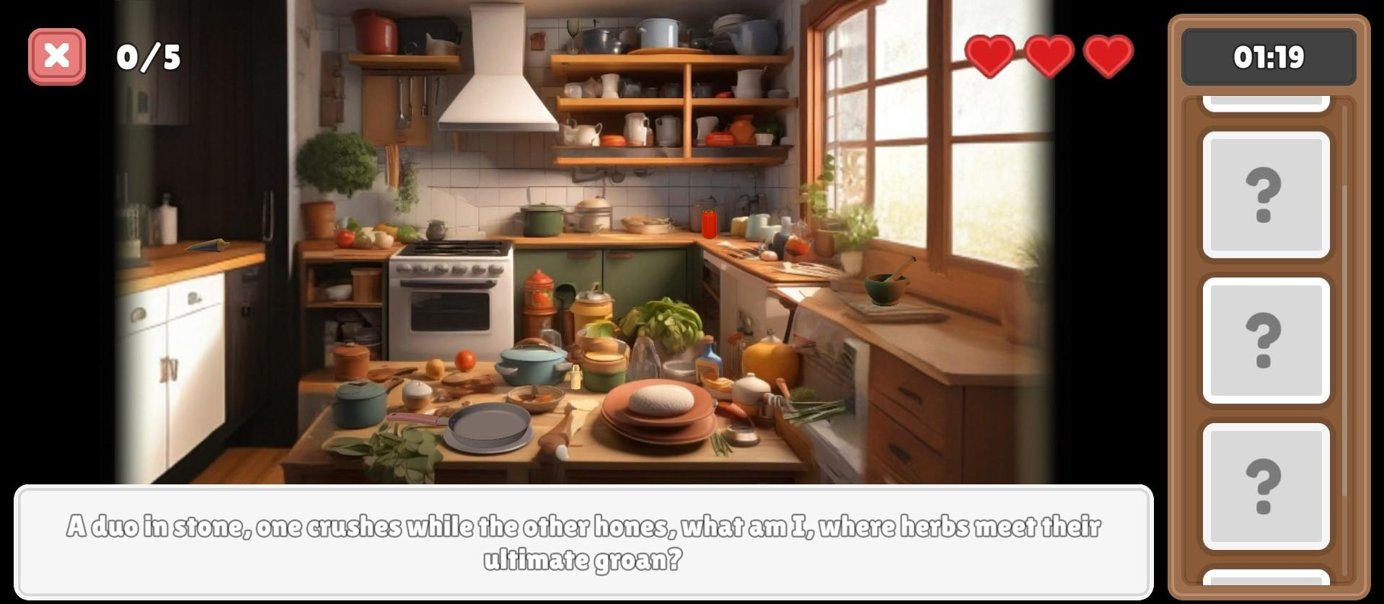
Figure 32 illustrates the gameplay mechanics of Mineral Quest, featuring an interactive selection of boxes to reveal object riddles. This gameplay mechanic is implemented using Unity UI elements and C# scripts to facilitate player interaction and content presentation.
Figure 33
Adventure Map
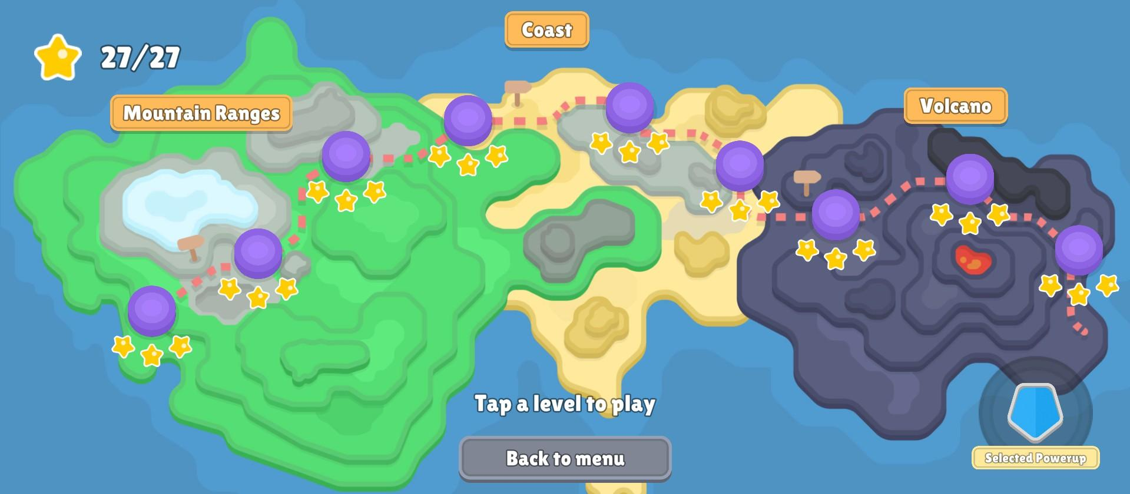
Figure 33 displays the Adventure mode map, organized into three rock classifications, each containing three levels. Local storage records star ratings per level, unlocking subsequent levels based on

accumulated stars. The power-up selection button allows access to purchased power-ups from the Shop, with data stored locally for accessibility.

Figure 34
Loading Screen Level
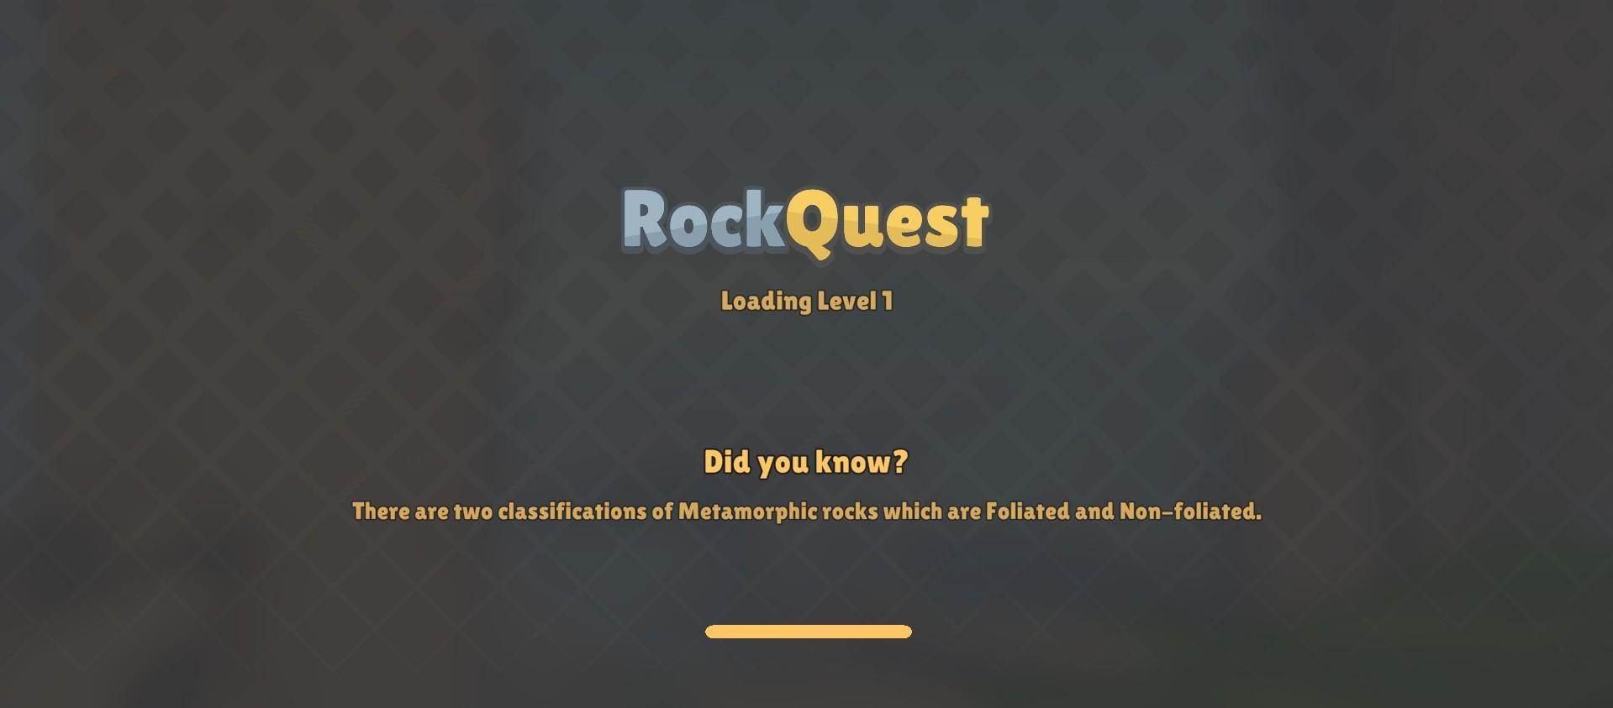

Figure 34 showcases the Adventure level loading screen, incorporating trivia about rocks or gameplay mechanics. Levels load asynchronously using Unity's SceneManager class, with a Coroutine updating a progress bar to visualize loading progress. Upon completion, the loaded level is displayed using Unity UI elements.

Figure 35
Mountain Ranges Gameplay
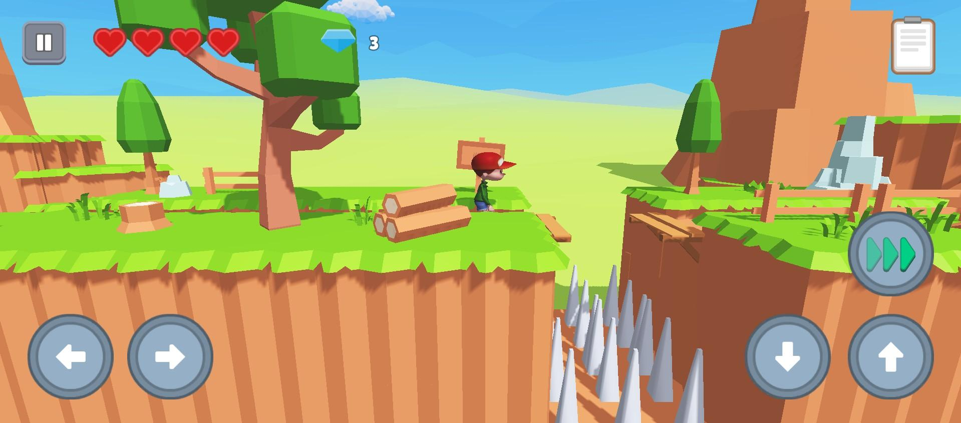
Figure 35 displays the gameplay for levels 1-3, Mountain Ranges, including power selection, adjustable buttons, hearts, settings, and objectives. A health manager script controls the player's hearts, decreasing them upon encountering enemies or obstacles. UI buttons facilitate mobile controls, while a 2D UI objective icon guides the player. Triggers are used for snakes and rolling rocks, while waypoint followers guide eagles and snakes.

Figure 36
Coast Gameplay
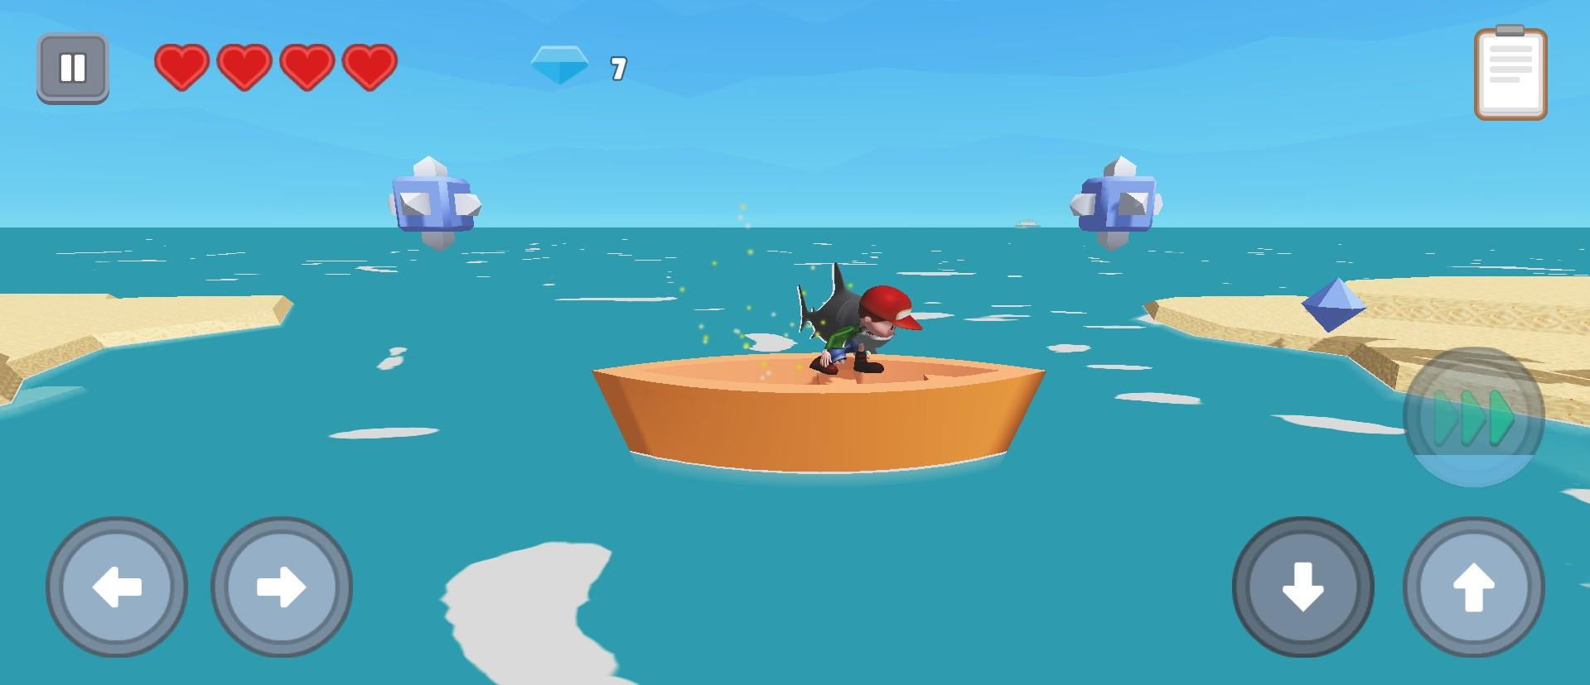

Figure 36 demonstrates gameplay for levels 4-6 in the Coast environment, featuring power selection, adjustable buttons, hearts, settings, and objectives. Enemy types include sharks, crabs, and seagulls, each controlled by collider triggers and scripts for detection and behavior. Various obstacles such as fans, boats, crocodiles, and crabs also utilize collider triggers. Waypoint followers guide the movement of boats, seagulls, and crabs to predetermined positions.

Figure 37
Volcano Gameplay
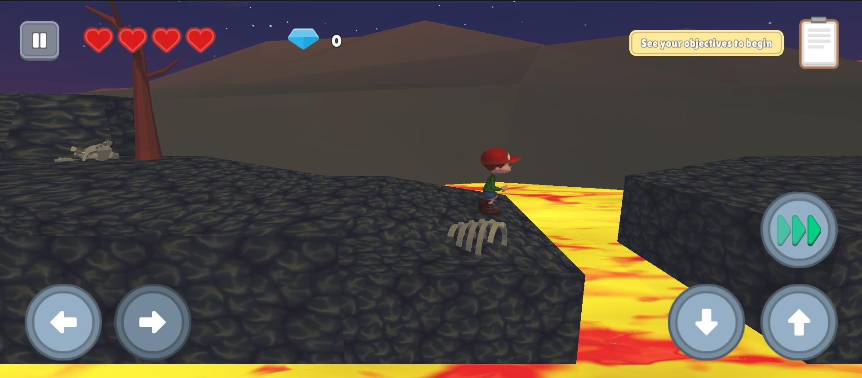
Figure 37 illustrates gameplay for levels 7-9 in the Volcano environment, featuring power selection, adjustable buttons, hearts, settings, and objectives. Enemy types include bats, controlled by collider triggers and scripts for detection and behavior. Various obstacles like shaking ground, sinking ground, tilting platforms, switching platforms, rolling magma rocks, and flip-swap platforms also utilize collider triggers for interaction. Scorpions and fireballs utilize waypoint followers for movement.

Projects Capabilities and Limitations

The mobile learning game Rock Quest is intended for Grade 11 Senior High School STEM Tracks students who have an Earth Science subject. The project is based on the K-12 Earth Science curriculum, with the game's content sourced from the DepEd Grade 11 Earth Science Module. The system consists of four main modules - Adventure mode, Almanac, Quiz, and Hidden Object Game designed to help students learn about rocks and minerals. Besides the four main modules, the game has a shop system and user information feature.
Rock Quest can only be played offline and does not use any form of database. The game is available only to Android users, limiting iOS users from accessing and playing the game.

Project Evaluation

Rock Quest is assessed based on ISO 9126 standards, which encompass six key qualities: Functionality, Reliability, Usability, Efficiency, Maintainability, and Portability, to ensure the quality of the application. ISO 9126 is an international standard for software evaluation and also serves as a framework for software quality control, quality assurance, and process improvement.

Table 12

Likert Scale

Equivalent Score | Percentage | Interpretation
6 | 5.17 - 6 | Strongly Agree
5 | 4.33 - 5.16 | Agree
4 | 3.50 - 4.32 | Somewhat Agree
3 | 2.67 - 3.49 | Somewhat Disagree
2 | 1.83 - 2.66 | Disagree
1 | 1.00 - 1.82 | Strongly Disagree

Table 12 displays the Likert Scale, used to analyze respondent feedback. A rating of six (6) corresponds to "Strongly Agree," indicating that users find the modules have met the standards of an efficient and effective mobile application.

Questionnaires

Appendix A presents the evaluation tool derived from ISO 9126, encompassing functionality, usability, reliability, portability, and efficiency. It caters to both students and Earth Science teachers, while also incorporating maintainability for IT professionals.

Frequency Distribution

Frequency distribution is used to organize and display data from the mobile game application survey. It shows the number and percentage of respondents, including students, IT professionals, and English teachers, providing insights into the survey population and aiding researchers in analyzing and interpreting the data.
Table 13

Respondent Frequency Distribution

Type of Respondent | Number of Respondent | Percentage
Student | 43 | 86%
IT Professional | 5 | 10%
Earth Science Teacher | 2 | 4%
Total | 50 | 100%

Table 13 presents the total number of respondents along with their respective percentages. It also shows the count of respondents for each type and designation.

Summary of Results

The summary of the evaluation results is based on the ISO 9126 standard. See Tables 14, 15 , and 16 respectively.

Table 14
Grade 11 STEM Track Students Average Result on ISO 9126

Criteria | Percentage Rating | Interpretation
Functionality | 5.41 | Strongly Agree
Usability | 5.32 | Strongly Agree
Reliability | 5.33 | Strongly Agree
Efficiency | 5.35 | Strongly Agree
Portability | 4.45 | Agree
Average Result | 5.17 | Strongly Agree

The data in Table 14 illustrates the mean evaluation outcomes for STEM Senior High School students. Based on the Likert scale applied in assessing ISO 9126, the average rating stands at 5.43, signifying a consensus leaning towards "Strongly Agree." This implies a robust agreement among the students regarding the ISO 9126 evaluation standards.
Table 15
Earth Science Teachers Average Result on ISO 9126

Criteria | Percentage Rating | Interpretation
Functionality | 5.35 | Strongly Agree
Usability | 6 | Strongly Agree
Reliability | 5.65 | Strongly Agree
Efficiency | 6 | Strongly Agree

Portability | 4.25 | Somewhat Agree
Average Result | 5.45 | Strongly Agree

Table 15 exhibits the average evaluation results for Earth Science teachers. Employing the Likert scale and ISO 9126 criteria for assessment, the average score tallied 5.45. This score signifies a "Strongly Agree" response, suggesting a substantial alignment among the surveyed Earth Science teachers concerning the ISO 9126 evaluation criteria.

Table 16
IT Professionals Average Result on ISO 9126

Criteria | Percentage Rating | Interpretation
Functionality | 5.56 | Strongly Agree
Usability | 5.40 | Strongly Agree
Reliability | 5.22 | Agree
Efficiency | 5.08 | Strongly Agree
Portability | 3.9 | Somewhat Agree
Maintainability | 5.14 | Agree
Average Result | 5.05 | Agree

Table 16 displays the average evaluation results for IT professionals. The assessment utilized the Likert scale and ISO 9126 criteria, resulting in an average score of 5.05. This score suggests an "Agree" response, indicating that the IT professionals surveyed generally agree with the ISO 9126 evaluation criteria.

Table 17

Summary Evaluation Results

Characteristics | Grade 11 STEM  Student | Earth Science Teacher | IT  Professiona l | Mean Average | Interpretation
Functionality | 5.31 | 5.41 | 5.56 | 5.47 | Strongly Agree
Efficiency | 5.35 | 6 | 5.08 | 5.48 | Strongly Agree
Usabiility | 5.32 | 6 | 5.40 | 5.57 | Strongly Agree
Reliability | 5.23 | 5.65 | 5.22 | 5.37 | Strongly Agree
Portability | 4.45 | 4.25 | 3.90 | 4.2 | Somewhat Agree
Maintainability | - | - | 5.14 | 5.14 | Agree
Mean Average |  |  |  | 5.22 | Strongly Agree

The mean average of the 6 qualities of ISO 9126 based on the evaluation results of
Grade 11 STEM students, Earth Science Teacher, and IT professional is 5.22, which indicates a Strongly Agree response.

Computing Standards and Modern Tools and Techniques Applied

- Computing Standards

ISO/IEC 9126 is an international standard used for assessing software quality. Rock Quest will be assessed based on six quality attributes: functionality, dependability, usability, efficiency, maintainability, and portability. Functionality is a crucial aspect of any product or service, enabling the software to perform tasks and fulfill its intended purpose by meeting the needs of the clients. Reliability assesses the software's ability to maintain consistent performance under various conditions. The Usability of a software relies heavily on the system’s functional capabilities. Efficiency focuses on the system's resource utilization when delivering desired functionality, defined by disk space, memory, and network usage. Maintainability refers to the software model's ability to identify and address defects easily through inspection. Portability refers to adaptable software that should easily adjust to environmental changes as frequently as needed.

- Modern Tools

Rock Quest was developed successfully using these modern tools. 1) Unity, a game engine and development platform for creating 2D and 3D games. 2) Blender, a free and open source software for 3D modeling and animations. 3) Mixamo, a character and animation store for game developers 4) Canva, a collaborative web application used to create other game assets. 5) Figma, a platform that lets you design, prototype, and develop storyboards and assets.
- Techniques Applied

The system Rock Quest utilizes the Fisher-Yates algorithm. The Fisher-Yates algorithm generates a random permutation of array elements by shuffling all the elements of an array at random and was implemented on the Quiz module of the game. This algorithm is commonly used

for shuffling arrays because of its efficiency and unbiased nature in generating random permutations. When used to shuffle quiz questions, it ensures that each question has an equal chance of appearing in any position within the quiz, thereby providing a fair and random distribution of questions. This randomness can help prevent patterns or biases in the question order, making the quiz more challenging and engaging for the participants.

Developmental Tools

Unity
Unity is selected as one of the developmental tools for game development due to its

cross-platform support, allowing the game to be deployed across various platforms. Its rich feature set, including graphics rendering, physics simulation, and audio management, provides comprehensive tools for creating engaging games. Additionally, Unity's Asset Store makes it an efficient choice for developing high-quality games for easy asset accumulation.

Blender

Blender is used because of its easy to learn 3D modeling features, which are ideal for creating detailed and realistic rock models as well as the games’ power ups, improving the game's visual quality and user engagement.

Mixamo

Mixamo is a web-based service provided by Adobe that offers a large collection of high-quality 3D characters and animations. Mixamo is utilized in the game to provide the game character and its animations, offering a convenient and efficient way to incorporate ready-made animated characters into the game.

Canva

Canva is a web-based graphic design platform that offers a wide range of tools and templates for creating various visual content. Canva was used to create custom 2D assets for the game, providing an accessible and user-friendly platform for designing graphics and visual elements for the game's aesthetic.

Figma

Figma is a cloud-based design tool used for creating user interfaces, websites, and app prototypes.Figma was used to visualize the game's storyboard modules, offering a collaborative platform for designing and organizing the game's narrative and structure.

Trade Offs

- File Compression vs. Load Times

Compressing game files can reduce the overall size of the game, making it quicker to download and reducing storage requirements. However, the researchers choose Load Time as heavy compression may result in lower quality graphics or longer load times as assets need to be decompressed during gameplay.

- Assets vs. Memory

In developing a mobile 3D game, researchers prioritize assets over memory, emphasizing detailed rock modeling for content reliability and a better gaming experience, despite potential memory constraints.

Multiple Constraints

The constraints faced by the researchers in developing the mobile game application are as follows:
  - Time Constraint

Time constraint is a significant limitation in the development of Rock Quest. The project has a strict deadline, adding pressure to complete all phases of development, from initial design to testing, and to evaluation within a limited timeframe. Effective time management is crucial to ensure the project progresses smoothly and meets the set deadlines.

  - Skill Constraint

Skill constraint is another significant challenge in the development of the mobile game application. As the proponents' track is in cybersecurity, transitioning to game development and mastering 3D modeling poses a considerable challenge. The unfamiliarity with game development tools and techniques requires additional learning and adaptation to meet the project's requirements.

  - Asset Availability Constraint

Asset availability is a notable constraint in the development of the mobile game application for the capstone project. Finding free assets suitable for the game is challenging, as purchasing assets can be costly and exceeds the project's budget.

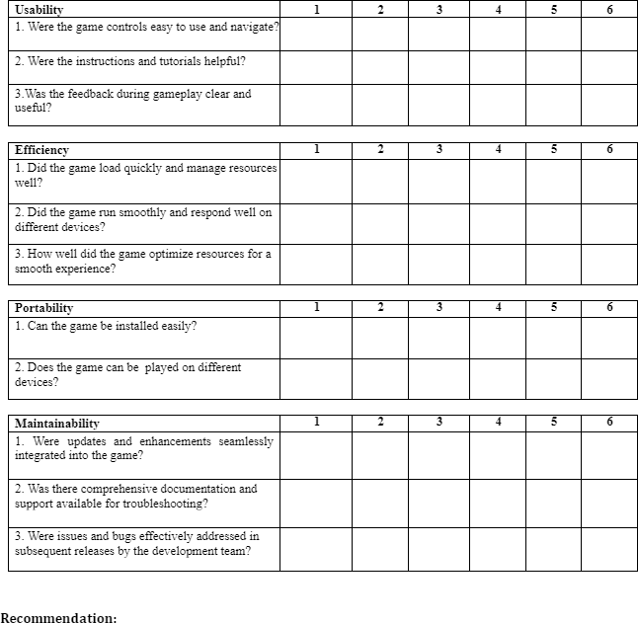

Questionnaire for Students and Earth Science Teacher



